Paula De Francisco Pérez  Marketplace Category · Seller Growth · Trend Curation  Dubai, UAE | +971 50 386 3656 | paulich98@hotmail.com  linkedin.com/in/paula-de-francisco-perez-92a13119a  Portfolio: paula-de-francisco.vercel.app  Nationality: Spanish | UAE Employment Visa (employer-sponsored) | 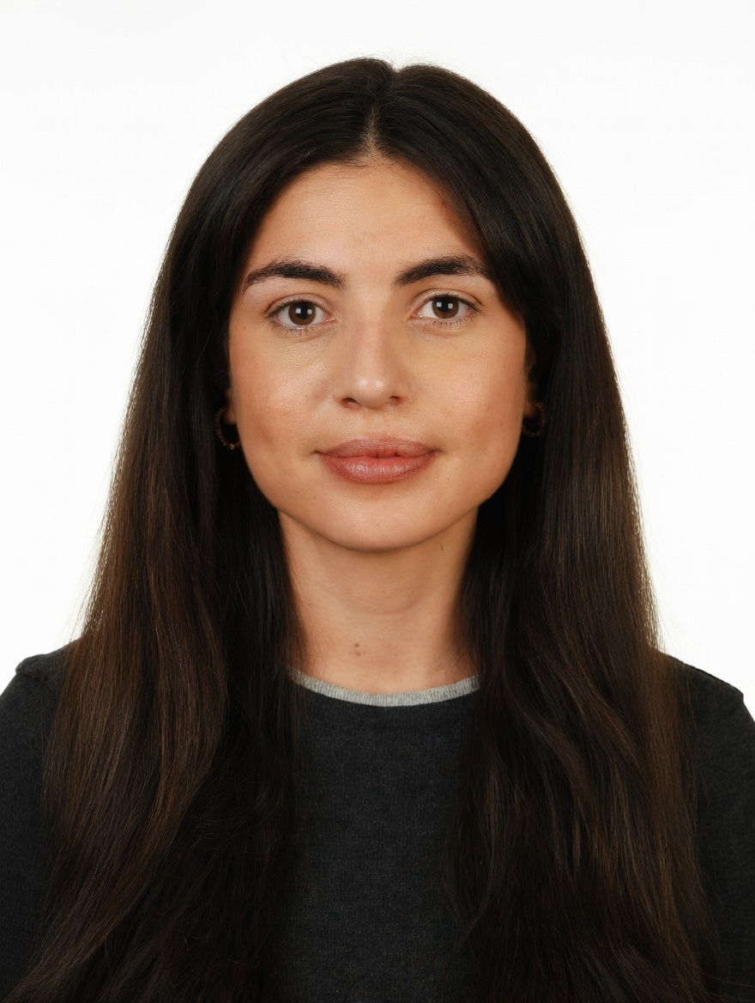
PROFESSIONAL SUMMARY

Marketplace category and key account manager with 5 years across beauty, fashion retail and e-commerce. At Alibaba's Miravia & AliExpress, grew 42 beauty and fragrance brands +30% GMV QoQ, onboarded 30+ sellers in two months and owned the Flash Sales channel against P&L targets. Now building creator and community programmes at DoFreeze; an active Vinted buyer and seller.
WORK EXPERIENCE

Brand & Marketing Manager | Oct 2025 – Present
DoFreeze LLC · UAE F&B / FMCG group | 7 brands incl. Befit, Eurocake, SMASH | sold on talabat, Noon, Careem · Dubai, UAE
• Lead marketing for 7 brands across 50+ markets with a team of two (designer, social media exec), incl. 6 product launches and listings and promotions on talabat, Noon and Careem
• Built the creator programme from zero (103 creator activations over 3 waves at AED 81 per content piece) and designed the Befit Crew affiliate programme with personal codes and tiered commissions
• Run community activations and events: running, padel and yoga club sessions, Saudi Food Show 2026, and a Sun & Sand Sports x Fabletics session that led to a listing proposal
• Judge everything on sell-out: SMASH x talabat lifted daily sales +165% vs +4.7% for a control brand; web orders +86% after adding reviews and basket-based bundles
Key Account Manager – Beauty, Fragrances & Fashion | Nov 2023 – Oct 2025
Miravia & AliExpress (Alibaba Group) · Marketplace | Beauty & Health department · Madrid, Spain
• Managed 42 beauty and fragrance brands (incl. L'Oréal Paris, Maybelline, NYX, Redken, KIKO Milano) to +30% GMV QoQ through pricing, assortment, promotions and on-site visibility
• Seller acquisition: spotted the Arabian-perfume trend and onboarded 30+ stores in two months, incl. the distributors of Lattafa, Arabian Oud, Swiss Arabian and Ajmal, making it a top-growing sub-category
• Owned the Flash Sales channel for Beauty, Fashion & Home (up to ~30% of B&H sales): off-price, time-limited deals and pricing, reporting to the CEO
• Created Hot on Social, a monthly trend-led showcase of seasonal products and brand promotions, and the Beauty Club; worked with marketing, product and ops
Account Manager – XL Accounts | Sep 2022 – Nov 2023
Glovo · Food & quick-commerce delivery app | 10K+ employees · Madrid, Spain
• Co-managed 5 XL restaurant partners (KFC, Taco Bell, Vicio): promotions, in-app visibility, fraud reviews, kitchen visits
Early Career | 2018 – 2022
Mondelez International · Massimo Dutti (Inditex) · Global FMCG | Premium fashion retail · Madrid, Spain
• Category Planning Trainee, Mondelez (Aug 2021 – Aug 2022): sell-in/sell-out and promo-effectiveness analysis, NPD support
• Sales Associate, Massimo Dutti (Jun 2018 – Jun 2019): Las Rozas Village factory store, premium off-price fashion retail
CORE SKILLS & TOOLS

Category | seller acquisition & onboarding, trend curation, key account management, pricing, flash sales
Marketplaces | Miravia, AliExpress, Noon, talabat, Careem, Amazon, Glovo, Shopify, on-site visibility, bundling
Creators & Community | creator & influencer programmes, affiliates, community events, sampling, UGC, product launches
Data & Analytics | P&L targets, GMV, sell-in/sell-out, promo uplift vs control, Excel (Expert), Looker, Power BI
Tools & AI | Claude (AI automation), ChatGPT, Canva, Photoshop, Meta Ads, Shopify
EDUCATION

Bachelor's in Business Administration — CUNEF Universidad, Madrid | 2016 – 2020
Specialisation: E-Commerce · Fashion Industry · Thesis on e-commerce in fashion retail (9.5/10)
Google E-Commerce Certificate · Google Digital Marketing Certificate
LANGUAGES

Spanish | Native | English | Professional C1

